# Mahad Ghauri

233523

Data Structures Lab Task-09

Insertion Sort:

#include <iostream>

using namespace std;

void displayArray(int arr[], int size)

{

for (int i = 0; i < size; i++)

{

cout << arr[i] << " ";

}

cout << endl;

}

void insertionSort(int arr[], int size)

{

for (int i = 0; i < size-1; i++)

{

int key = arr[i+1];

int j = i;

while (j >= 0 && arr[j] > key)

{

arr[j + 1] = arr[j];

j--;

}

arr[j + 1] = key;

}

}

int main()

{

int arr[] = {29, 10, 14, 37, 13, 45, 22, 7, 2, 11};

int size = sizeof(arr) / sizeof(arr[0]);

cout << "Original Array: ";

displayArray(arr, size);

int insertionArr[size];

copy(arr, arr + size, insertionArr);

insertionSort(insertionArr, size);

cout << "After Insertion Sort: ";

displayArray(insertionArr, size);

return 0;

}

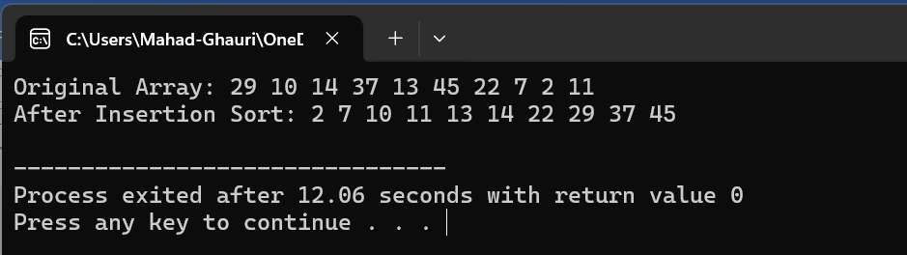

Selection Sort:

#include <iostream>

using namespace std;

void displayArray(int arr[], int size)

{

for (int i = 0; i < size; i++)

{

cout << arr[i] << " ";

}

cout << endl;

}

void selectionSort(int arr[], int size)

{

for (int i = 0; i < size - 1; i++)

{

int minNumber = i;

for (int j = i + 1; j < size; j++)

{

if (arr[j] < arr[minNumber])

{

minNumber = j;

}

}

swap(arr[i], arr[minNumber]);

}

}

int main()

{

int arr[] = {29, 10, 14, 37, 13, 45, 22, 7, 2, 11};

int size = sizeof(arr) / sizeof(arr[0]);

cout << "Original Array: ";

displayArray(arr, size);

int selectionArr[size];

copy(arr, arr + size, selectionArr);

selectionSort(selectionArr, size);

cout << "After Selection Sort: ";

displayArray(selectionArr, size);

return 0;

}

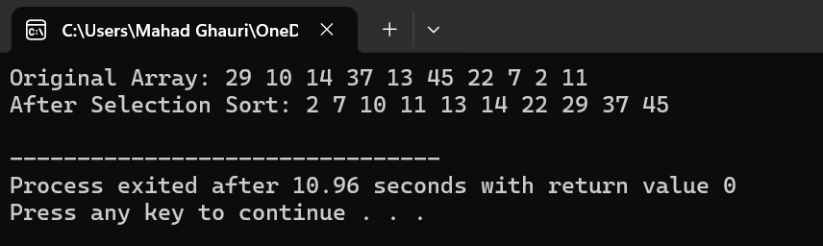

Bubble Sort:

#include <iostream>

using namespace std;

void displayArray(int arr[], int size)

{

for (int i = 0; i < size; i++)

{

cout << arr[i] << " ";

}

cout << endl;

}

void bubbleSort(int arr[], int size)

{

bool swapped = false;

while (true)

{

swapped = false;

for (int j = 0; j < size - 1; j++) {

if (arr[j] > arr[j + 1]) {

swap(arr[j], arr[j + 1]);

swapped = true;

}

}

size--;

if (!swapped)

{

break;

}

}

}

int main() {

int arr[] = {29, 10, 14, 37, 13, 45, 22, 7, 2, 11};

int size = sizeof(arr) / sizeof(arr[0]);

cout << "Original Array: ";

displayArray(arr, size);

int bubbleArr[size];

copy(arr, arr + size, bubbleArr);

bubbleSort(bubbleArr, size);

cout << "After Bubble Sort: ";

displayArray(bubbleArr, size);

return 0;

}

